HERMAN MILLER
DEALER LIST

https://www.hermanmiller.com/where-to-buy/contact-a-dealer/?q=Idaho

Henriksen/Butler Design Group, LLC-Boise
Zach Fronk
zfronk@henriksenbutler.com
or
Jeff Clarke
jclarke@henriksenbutler.com
401 W Idaho Street
Boise, ID 83702

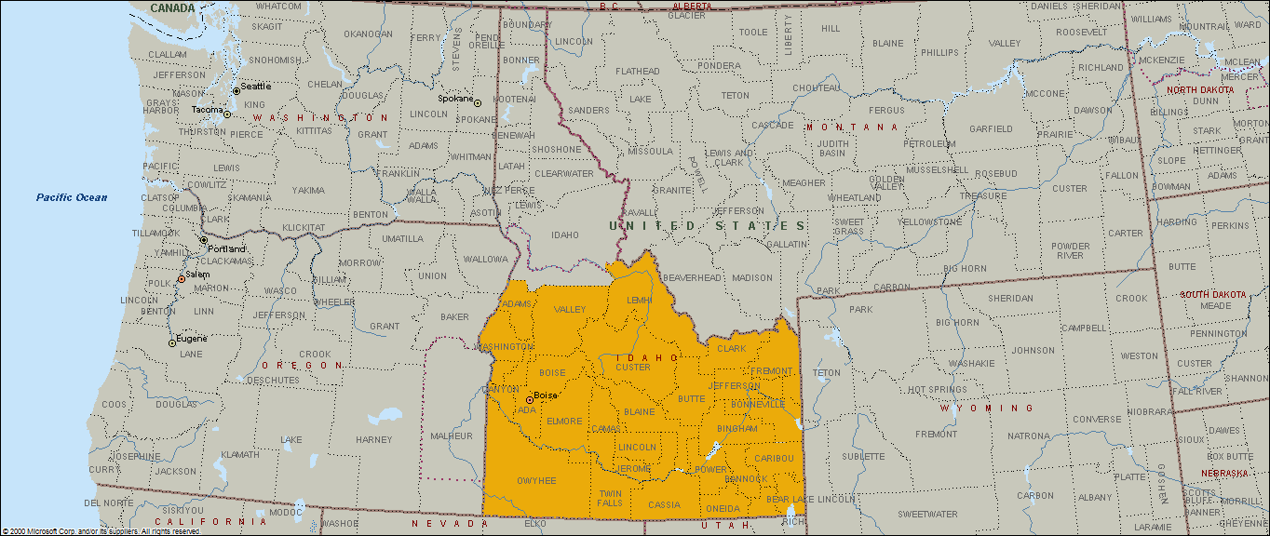

CDA-Contract Design Associates
Gwen Marlow
gwen@cdainteriors.com
402 E. Sprague Avenue
Spokane, WA 99202

