Athena Consulting, LLC: Info Sheet
SBPO20200077
Temporary Staffing Services
STATE OF IDAHO

The information provided in this Info Sheet is for Athena Consulting, LLC only. Information will vary on a contract by contract basis.

CATEGORIES & REGIONS AWARDED:

- Mandatory Use Positions: Administrative Support
  - Region 1, Region 2, Region 3, Region 4, Region 5, Region 6

- Optional Use: Commercial/Industrial
  - Region 1, Region 2, Region 3, Region 4, Region 5, Region 6

- Optional Use: Healthcare Services
  - Region 1, Region 2, Region 3, Region 4, Region 5, Region 6

- Optional Use: Professional Services
  - Region 1, Region 2, Region 3, Region 4, Region 5, Region 6

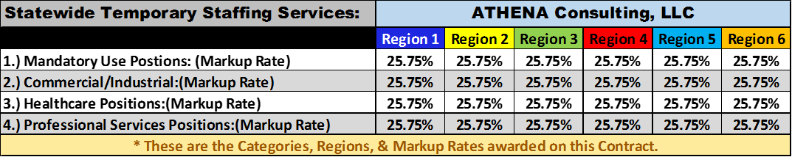

CONTACT INFORMATION:

MAIN POINT OF CONTACT:
Lisa Davis
VP of Operations
Telephone: 301-216-9654
Email: ldavis@athenaconsultingllc.com

