Beatty's Services, Inc: Info Sheet
SBPO20200078
Temporary Staffing Services
STATE OF IDAHO

The information provided in this Info Sheet is for Beatty's Services, Inc only. Information will vary on a contract by contract basis.

CATEGORIES & REGIONS AWARDED:

- Mandatory Use Positions: Administrative Support
  - Region 1, Region 2, Region 3, Region 4, Region 5, Region 6

- Optional Use: Professional Services
  - Region 1, Region 2, Region 3, Region 4, Region 5, Region 6

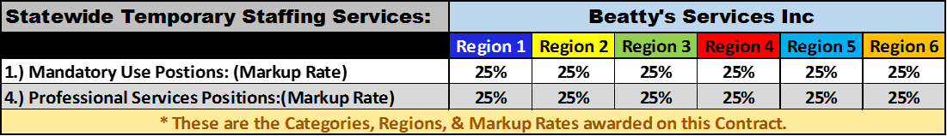

CONTACT INFORMATION:

POINT OF CONTACT FOR ORDERS:

Heather Thompson- Project Coordinator
800-878-9658x4
212-932-2063
temp orders@beattys2.com
M, T, W, 9am-6pm-800-878-9658 or 646-483-4254
TH & F and After-hours: 646-483-4254
(New York)

ADDITIONAL POINTS OF CONTACT:

Myneika White- President, CEO
800-878-9658 x3
201-887-8737
Email Address: myneikab@beattys2.com
M, T: 8-6pm ET
W, TH: 11am-7pm PST
F: Off (Will accept calls 24hrs)
(California)

LaShanda Beatty- CAO
800-878-9658x1
212-932-0547
201-937-7155
Email Address:memployment@beattys2.com
payroll@beattys2.com
M, T: 9am-5pm(New Jersey)
W, TH: 9am -5pm (New York)

