Lawson Products, Inc. Info Sheet

Contract # SBPO20200087

CONTRACT OVERVIEW

FACILITIES MRO (Maintenance, Repair and Operations)

STATE OF IDAHO

The information provided in this Info Sheet is for Lawson Products, Inc. only. Information will vary on a contract by contract basis.

CATEGORY AWARDS

|  |  |
| --- | --- |
| **Lawson Products, Inc.** | **Cat 5 Fasteners** |

AWARDS BY CATEGORY

All Areas (A, B & C) for all awarded categories.

CATEGORY DISCOUNT PERCENTAGES

This percent discount will be the minimum allowable discount on Contract purchases for all purchases in the designated Area, within that category. These discounts will be considered “Ceiling Pricing” in that a Contractor may increase the discount, or provide more advantageous pricing in any way for any reason (example: high quantity, large dollar single purchase, etc.).

|  |  |  |  |
| --- | --- | --- | --- |
| **Mandatory Use Categories:** | **Area A** | **Area B** | **Area C** |
| 5. Fasteners | 74.368 % | 74.368 % | 74.368 % |

CONTACT INFORMATION:

**MAIN POINT OF CONTACT BACKUP POINT OF CONTACT:**

Christina Nielsen Ryan Mullally

Director, Government Accounts Government Sales Account Manager

800-890-8198 469-400-7400

christina.nielsen@lawsonproducts.com [ryan.mullally@lawsonproducts.com](mailto:ryan.mullally@lawsonproducts.com)

**FOR INVOICING ISSUES:**

NeDra Brewer

Supervisor – Customer Contact Center

773-304-5239

billing.support@lawsonproducts.com

PHYSICAL LOCATIONS:

Lawson has six state-of-the-art distribution centers across the US and Canada. Lawson ships 99% of all lines complete within 24 hours from these six distribution centers and also offers will-call services at each center. Lawson ships FOB Destination for standard shipping methods. Lawson can guarantee next day delivery in an emergency utilizing air freight service, if necessary. Lawson Products Distribution Centers are full stocking. Lawson Customer Pick-Up service in an emergency to pick up the necessary parts is available at our Distribution Centers through our will-call window. The following illustration demonstrates the geography serviced by each distribution center in the US.

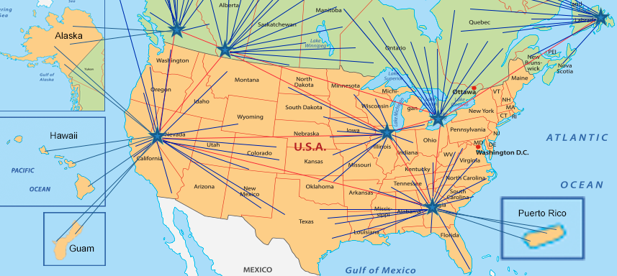USA

Lawson McCook – size: 420,000 SF

8801 W. 47th St.

McCook, Illinois 60525

708-225-0100

Lawson Suwanee – size: 101,800 SF

1197 Satellite Blvd.

Suwanee, Georgia 30024

Lawson Reno – size: 111,248 SF

1381 Capital Boulevard

Reno, Nevada 89502

ORDERING INFORMATION:

**HOW TO PLACE AN ORDER ONLINE:**

* **Log into your State of Idaho agency Lawson account number at:** [www.lawsonproducts.com](http://www.lawsonproducts.com)

1. Click on LOGIN/REGISTER link at the top left corner of the web page.



2. On the page that opens up next, click on “Yes, my organization has an account” and enter organization account number and zip code in the spaces provided and click “Next” button.



3. On the next page, fill out your details in the “Your Information” section. Choose a user ID, password, and security question to secure your account. Please choose a user ID and password that are easy to remember.



4. Agree to the terms and conditions and click the “Submit” button to save the information and create your account.



* **For registration support, contract the Lawson Web Customer Care Team at** [**WebCustomer.Care@lawsonproducts.com**](mailto:WebCustomer.Care@lawsonproducts.com) **or call Web Customer Care Team at 773.304.5050 ext. 70082**

**HOW TO PLACE AN ORDER OVER THE PHONE:**

Phone: 866.837.9908

**HOW TO PLACE AN ORDER VIA FAX:**

Fax: 800.942.5260

**HOW TO PLACE AN ORDER IN PERSON:**

The Lawson Sales Representative is your front line product and application expert. Our representatives are the most experienced in the industry and they will identify and evaluate problem areas on-site and recommend innovative product solutions and applications. They are backed by our full team of Technical and Engineering professionals. Your representative will call on your locations on a pre-approved schedule to re-sort the bins where parts or fasteners have been returned and thrown into the wrong slot.  Lawson does this through our current Rep Service Model and our Onsite distribution and supply stocking services, also known as Vendor Management of Inventory (VMI) at no additional cost.  Lawson Products will be asking sales reps to stop by many of your locations to introduce themselves and see if they can assist you.  If you would like to see a sales rep right away please contract our Customer Service Department (Phone: 866.837.9908) so we can notify the local Sales Representative in your area.

CATEGORY DESCRIPTIONS:

Allowable products for each category are detailed below:

**MANDATORY USE CATEGORIES:**

**CATEGORY 5. Fasteners:** *UNSPSC Code 3116*

The products allowed in this category include but are not limited to: nuts, bolts, screws, nails, ties, washers, anchors, rivets, spacers, pins, extractors, etc. **No installation, maintenance or repair services are included.**

**AREAS:**

Areas are demonstrated by the map below:

