Agriculture & Turf Division

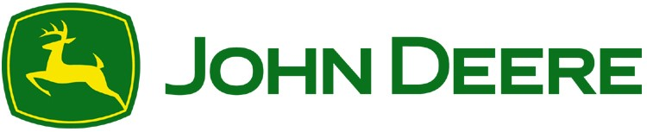

2000 John Deere Run

Cary, NC 27513

Phone: 919 804 2000

March 1, 2025

**Ordering Instructions for Contract # PADD20257087**

1. Customers can locate their local John Deere dealer by utilizing [www.deere.com.](http://www.deere.com/) Simply select “**Find a Dealer**” found at the top of the webpage and then enter the zip code to find the nearest dealer. The dealer information displayed will include an email address, telephone number and physical address.

1. Customers may also contact John Deere’s Government Sales Department at (800) 358-5010 – Option 2 or CorpAcctGovSupport@JohnDeere.com. If the Government Sales Department is contacted, we will direct the customer to their nearest dealer.

1. The John Deere dealers will prepare all contract quotes. The dealers are the equipment experts when it comes to matching up the right equipment to fit the customer’s needs.

1. Once the quote from the dealer has been obtained, the customer will submit their purchase order (PO) to the dealer. The PO will be made out as follows: **Deere & Company 2000 John Deere Run, Cary NC 27513**. The PO should reference the contract number and the delivering dealer.

1. The dealer will submit the PO, the quote and the tax exemption certificate, if applicable, to John Deere electronically for auditing and processing. Once the paperwork has passed audit, the dealer will be given approval by the Order Management Team to deliver the equipment or to order the equipment if it’s not in inventory.

1. Deere & Company will invoice the customer after the equipment has been delivered by the dealer.

Customer Service Contact Information:

John Deere Government Sales Order Management Team

2000 John Deere Run

Cary, NC 27513

CorpAcctGovSupport@JohnDeere.com (800) 358-5010 – Option 2

Public