Personnel Plus, Inc: Info Sheet
SBPO20200081
Temporary Staffing Services
STATE OF IDAHO

The information provided in this Info Sheet is for Personnel Plus, Inc only. Information will vary on a contract by contract basis.

CATEGORIES & REGIONS AWARDED:

- Mandatory Use Positions: Administrative Support
  - Region 3, Region 4, Region 5

- Optional Use: Healthcare Services
  - Region 3, Region 4, Region 5

- Optional Use: Professional Services
  - Region 3, Region 4, Region 5

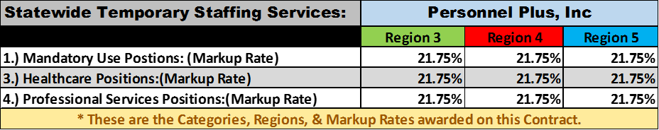

CONTACT INFORMATION:

Region 3: Ada, Adams, Canyon, Elmore, Gem, Owyhee, Payette, Valley, and Washington counties.

Primary Contact: Piper Chase 208-378-8700 pchase@personnel.com
Secondary Contact: Jose Sauceda 208-378-8700 jsauceda@personnel.com

Region 4: Blaine, Camas, Cassia, Gooding, Jerome, Lincoln, Minidoka, and Twin Falls counties.

Primary Contact: Lori Delgado 208-678-4040 ldelgado@personnel.com
Secondary Contact: Kim Zavala 208-733-7300 kzavala@personnel.com

Region 5: Bannock, Bear Lake, Bingham, Caribou, Franklin, Oneida, and Power counties

Primary Contact: Lori Delgado 208-678-4040 ldelgado@personnel.com
Secondary Contact: Laura Zamora 208-678-4040 lzamora@personnel.com

