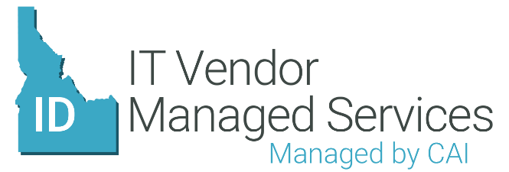
Program Benefits Overview
- Single procurement vehicle for staff augmentation needs
  - Streamlines overall process through a single point of contact
  - Simplified invoicing process, all handled through CAI
  - CAI’s performance is managed through contractual service level agreements
  - Significant reduction in “time to hire” through proven workflow process
- Full-service approach
  - Workflow process is handled via Vendor Management System (VMS)
  - CAI advises in identifying and classifying needs
  - CAI screens and performs initial qualification of candidates submitted by vendor network, but final selection still rests in the hands of the State
  - CAI handles communication with and administration of vendors
  - CAI removes administrative burden from the State, allowing managers to focus on other critical tasks
- Robust Vendor Management System (VMS) in VectorVMS
  - VectorVMS provides for full transparency throughout the program lifecycle
  - Entire end-to-end process is handled through the VMS
  - Detailed reporting is available on thousands of data points, enabling the State to make better informed business decisions
  - CAI handles configuration and maintenance of the VMS
- Open vendor network
  - Open network allows for greater flexibility and increased access to niche technologies
  - Enables enhanced utilization of Idaho-based companies
  - CAI manages documentation and compliance of vendor network

